23CSE111 OBJECT ORIENTED PROGRAMMING
S2 B.Tech CSE
Department of Computer Science and Engineering
Amrita School of Computing, Amritapuri Campus
CASE STUDY
PHASE – I & PHASE – II
Analysis and Architectural Modelling (CO1 & CO2)
Group No : A2
Team Members :
Roll No | Student Name
AM.SC.U4CSE25009 | Adabala Nagalakshmi
AM.SC.U4CSE25063 | C. Lasya
AM.SC.U4CSE25066 | Prathijna Mahalingan
AM.SC.U4CSE25069 | Chokkapu Gayatri

PHASE – I (Analysis)
Problem Identification & Class Mapping (CO1)
1. Problem Title : Digital Marksheet Generator
2. Problem Description :
Educational institutions generate marksheets for students after examinations. A digital marksheet system stores student marks and calculates grades automatically.
The system should allow:
- Enter student marks
- Calculate total marks
- Assign grades
- Generate marksheet

3. Identified Entities (Classes)
Class Name | Description
User | Stores common user details such as username, name, role, and security information.
Student | Represents a student with student ID, department, and attendance information.
Teacher | Represents a teacher with department and teacher ID details.
Attendance | Manages attendance records and calculates attendance percentage and eligibility.
Subject | Stores subject details along with marks and highest marks obtained.
Result | Defines common methods for calculating total marks and grades.
Marksheet | Manages a student’s marks, subjects, status, remarks, and grade calculation.
AuthService | Handles user registration, login, authentication, and password reset operations.
DatabaseManager | Manages database connection, table creation, and all database-related operations.
LoginPanel | Handles user authentication by providing login, registration, and password reset interfaces for students and teachers.
MainApplication | Acts as the entry point of the system and initializes the application, database connection, and main GUI flow.
StudentDashboard | Allows students to view their marksheets, attendance details, academic status, and request corrections.
Teacherdashboard | Provides teachers with functionalities to manage students, generate marksheets, update attendance, and configure department settings.

4. Class Attributes and Behaviours
Class Name | Attributes | Methods (Behaviours)
User(Abstract) | username, name, role, securityQuestion, securityAnswer | User()  setSecurityQuestion()  getSecurityQuestion()  setSecurityAnswer()  getSecurityAnswer()  getUsername()  getName()  getRole()
Teacher | department, teacherId | Teacher()  Teacher()  getTeacherId()  getDepartment()
Student | studentId, department, attendance | Student()  setAttendance()  getAttendance()  getStudentId()  getDepartment()
Attendance | totalClasses, attendedClasses | Attendance()  calculatePercentage()  isEligible()  getTotalClasses()  getAttendedClasses()
Subject | subjectName, marks, highestMarks | Subject()  Subject(  setMarks()  isValidMarks()  getSubjectName()  getMarks()  getHighestMarks()  setHighestMarks()
Result(Abstract) |  | calculateTotal() (abstract)  calculateGrade() (abstract)
Marksheet | student, subjects<list>, status, remark, institutionName, institutionAddress, teacherId, maxMarksPerSubject, correctionRequested, correctionDetails | Marksheet()  getInstitutionName()  setInstitutionName()  getInstitutionAddress()  setInstitutionAddress()  getTeacherId()  setTeacherId()  getMaxMarksPerSubject()  setMaxMarksPerSubject()  isCorrectionRequested()  setCorrectionRequested()  getCorrectionDetails()  setCorrectionDetails()  addSubject()  getSubjects()  getStudent()  getStatus()  setStatus()  getRemarks()  setRemarks()  calculateTotal()  calculateGrade()
AuthService | LEGACY_SEEDED_TEACHER_USERNAME, OLD_SEEDED_TEACHER_USERNAME, userCredentials, userDetails | AuthService()  removeDefaultTeacherAccounts()  removeDefaultTeacher()  register()  login()  resetPassword()  getSecurityQuestion()
DatabaseManager | DB_CONFIG, DEFAULT_DB_URL, DB_URL, DB_USER, DB_PASS, connection, tablesCreated, databaseAvailable, lastConnectionError | DatabaseManager()  connectDatabase()  isDatabaseAvailable()  getLastConnectionError()  closeDatabase()  getConnection()  getConfig()  loadDatabaseConfig()  buildConnectionError()  createTables()  ensureColumn()  saveUsers()  loadUsers()  deleteUser()  getDepartmentSubjects()  getDepartmentTotalClasses()  saveDepartmentSettings()  saveMarksheet()  readMarksheet()  saveMarksheet()  deleteMarksheet()  addStudent()  getStudent()  getAllStudents()  getDepartment()  getTeacherId()
LoginPanel | app, authService | LoginPanel()  setupUI()  showSignUpDialog()  showForgotDialog()
MainApplication | cardLayout, mainPanel, loginPanel, teacherDashboard, studentDashboard | MainApplication()  showScreen()  showTeacherDashboard()  showStudentDashboard()
StudentDashboard | app, nameLabel, idLabel, deptLabel, attLabel, statusLabel, gradeLabel, totalLabel, instNameLabel, instAddrLabel, teacherLabel, marksPanel, currentMarksheet, centerPanel | StudentDashboard ()  setupUI()  makeKeyLabel()  makeDetailLabel()  loadStudentData()  makeColHeader()  makeColCell()
TeacheDashboard | STATUS_PENDING, STATUS_GENERATED, STATUS_NOT_ELIGIBLE, STATUS_ABSENT, STATUS_INVALID_MARKS, STATUS_INVALID_DUPLICATE_ID, app, table, tableModel, institutionName, institutionAddress, teacherId, teacherDepartment, defaultTotalClasses, maxMarksPerSubject, isMarksEditable, isTotalClassesEditable, isAllLocked, editableRow | TeacherDashboard()  setupUI()  updateTableColumns()  registerSubjectHeaderEditor()  editSubjectName()  refreshTableColumnsKeepingRows()  saveDepartmentSettings()  findSubjectsSavedForDepartment()  promptForInitialSubjects()  createStyledButton()  setEditableRowFromSelection()(0  cellText()  parseValidMarks()  hasBlankMarks()  hasInvalidMarks()  findInvalidOrDuplicateIdRows()  validateRowForMarksheet()  loadData()  calculateHighestMarks()  calculateHighestMarks()  showStatistics()  showCorrectionRequests()  generateMarksheets()  promptForMarksheetDetails()  viewMarksheet()  showMarksheetDialog()  mkMsHeader()  mkMsCell()  saveAll()

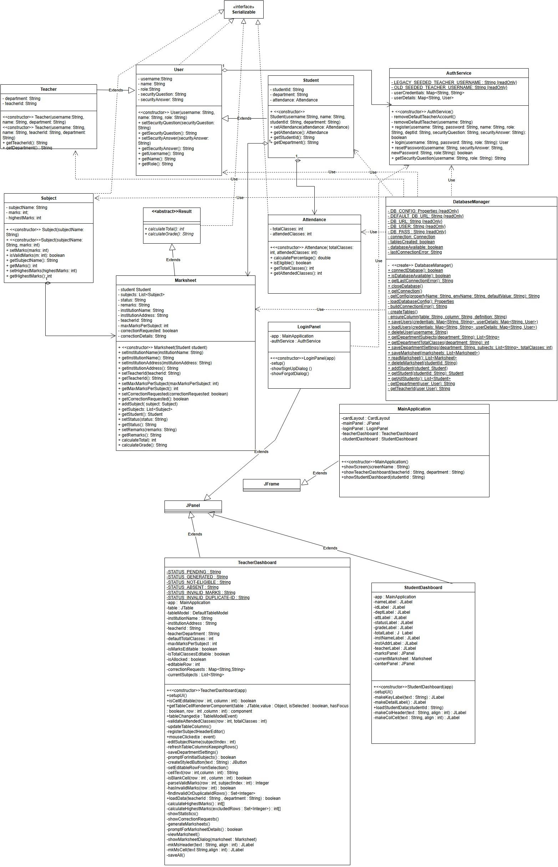
3. Sequence Diagram
Paste / Draw the Sequence Diagram here

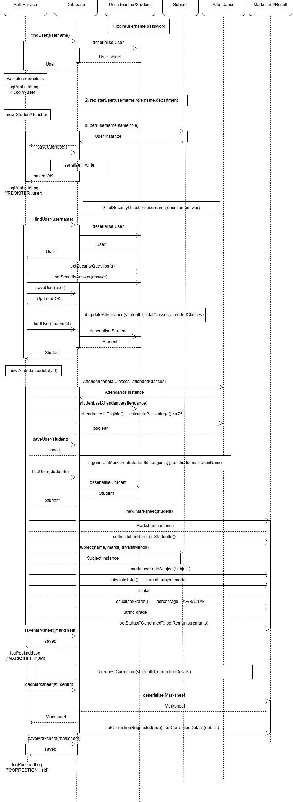

4. Brief Explanation of the Design
- Major classes identified and their responsibilities:
- Relationships used (association / aggregation / inheritance, if any):
- Key interaction flow captured in the sequence diagram:

- Major Classes and Their Responsibilities:
- User
  - Serves as the parent abstract class for Student and Teacher.
  - Stores common user information like username, name, role, and security details.
- Teacher
  - Stores teacher-related details such as teacher ID and department.
  - Represents teacher users who manage students, marksheets, and department settings.
- Student
  - Stores student-related information such as student ID, department, attendance, and personal details.
  - Represents a student user and connects student data with marksheets and attendance records.
- Subject
  - Stores subject name, marks obtained, and highest marks.
  - Validates marks data before storing it in the system.
- Result
  - Represents the final academic outcome of a student based on marks and attendance.
  - Stores result status such as pass, fail, or remarks-related information.
- Marksheet
  - Stores complete academic details of a student including subjects, attendance, remarks, and status.
  - Calculates and manages student result-related information.
- Attendance
  - Stores total classes and attended classes of students.
  - Helps track attendance percentage and academic eligibility.
- AuthService
  - Handles user registration, login, and password reset functionalities.
  - Manages authentication logic and communicates with DatabaseManager for user data storage.
- DatabaseManager
  - Handles database connectivity, table creation, and SQL operations.
  - Performs CRUD operations for users, marksheets, departments, and students.
- LoginPanel
  - Provides GUI interfaces for login, registration, and password recovery.
  - Connects frontend user actions with backend authentication services.
- MainApplication
  - Acts as the starting point of the application.
  - Initializes database connection and launches the GUI system.
- StudentDashboard
  - Allows students to view marksheets, attendance, and academic details.
  - Provides options for correction requests and result viewing.
- TeacherDashboard
  - Allows teachers to manage students, attendance, subjects, and marksheets.
  - Provides functionalities for updating academic records and department settings.

- Relationships Used:
- Association
- Student → Marksheet: A student has a marksheet. ( 1 → 1)
- TeacherDashboard → Marksheet: Teacher dashboard generates and manages marksheets.
- AuthService → DatabaseManager: AuthService communicates with DatabaseManager for storing and retrieving user details.
- StudentDashboard → Marksheet: Student dashboard displays marksheet details.
- Aggregation
- Teacher → Student
- Teacher manages students but does not own them
- Student → Attendance:Attendance belongs to a student record.
- Composition:
- Marksheet → Subject: A marksheet strongly contains multiple subjects.
- Inheritance:
- Student extends User
- Teacher extends User
- Marksheet extends Result
- TeacherDashboard extends JPanel
- StudentDashboard extends JPanel
- MainApplication extends JFrame
- Interface Implementation
- User implements Serializable
- Abstraction:
- User is an abstract class that stores common properties and methods shared by Student and Teacher.
- Result is an abstract class that defines common result-related methods such as:
calculateTotal()
calculateGrade()
- Marksheet inherits and implements these methods from Result.
- Multiplicity
- One Student → one Marksheet(1 → 1)
- One Teacher → Many Students(1 → *)
- One Marksheet → Many Subjects (1 → *)

- Key Interaction Flow (Sequence Diagram):
The system works step-by-step like this:
- Step 1: User Login
- User enters login credentials through LoginPanel.
- LoginPanel sends login request to AuthService.
- AuthService verifies credentials using DatabaseManager.
- Step 2: Dashboard Navigation
- If the user is a teacher:
MainApplication opens TeacherDashboard.
- If the user is a student:
MainApplication opens StudentDashboard.
- Step 3: Student and Subject Creation
- Teacher enters:
Student details
Subject names
Marks
Attendance details
- Objects created:
Student
Subject
Attendance
- Step 4: Marksheet Generation
- TeacherDashboard creates a Marksheet object using:
Student details
Subject list
Attendance
- Marksheet performs:
calculateTotal()
calculateGrade()
- Step 5: Database Storage
- DatabaseManager stores:
Student details
Attendance
Grade
Remarks
Marksheet information
- Step 6 : Student View
- Student logs in through LoginPanel.
- StudentDashboard retrieves marksheet details from DatabaseManager.
- Student can:
View marks
View grades
Check attendance
Request corrections

